**Field Project**

**Nature’s Nest**

##### O7 SERVICES

##### A Field Project Report

Submitted in partial fulfilment of the requirements for the

##### Award of the degree of

#### “Bachelor of Computer Applications”

#### By

#### Mandeep Kaur

#### (Registration Number: 22307625485)



**Centre for Distance and Online Education**

# LOVELY PROFESSIONAL UNIVERSITY PHAGWARA, PUNJAB

##### Year 2025

##### Contents of Report

1. Cover page– as per Annexure–I………………………………………………………………………..1
2. Declaration by student (as per Annexure–II) …………………………………………………………..4
3. Training completion certificate from organization /Company (as per Annexure–III)………………….5
4. Acknowledgement…………………….………………………………………………………………………… 6
5. List of figures……………………………………………………………………………………………………..7
6. List of abbreviations………………………………………………………………………………………………8
7. Chapter-1 INTRODUCTION TO THE PROJECT………………………….……………………….…9

1.1 Objective and work undertaken ...……………………………………………………………..… 9

1.2 Scope and Work ……………………………………………………………………………..…... 9

1.3 Importance and Applicability…….……………………………………………………………. 10

1.4 Role ……………...……………………………………………………………………………... 10

1. Chapter–2 INTRODUCTION TO THE COMPANY………………...………………………………..11

2.1 Company Profile ……………………………………………………………………………...…11

2.2 Project Done …..…………………………………………………………………………….…..12

1. Chapter - 3 DESCRIPTION OF WORK DONE………………………………………………………13

3.1 HTML …………………………………………………………………………………….……..14

3.2 CSS………………………………………………………………………………………………15

3.3 Java Script………………………………………………………………………………………..18

3.4 Bootstrap ………………………………………………………………………………………...20

3.5 Angular ………………………………………………………………………………………….24

3.6 Firebase……….………….………………………………………………………………………29

3.7 Cloud firestore ....……….………………………………………………………………………..31

3.8 Firebase Authentication………………………………………………………………………….32

3.9 Cloudinary ……………………………………………………………………………..………. 34

3.10 Tools and Technology used……………………………………………………………………...35

1. Chapter- 4 MY PROJECT

4.1 Main page……………………………………………………………………………………….. 37

4.3 Login Page……………………………………………………………………………………….38

4.5 Register Page ………………….……………………………………………………………….. 39

4.7 Register & Login Services File ………………………………………………………………… 40

4.11 Routing Page …………………………………………………………………………………… 42

4.12 Firebase Database ……………………………………………………………………………… 44

4.14 DFDs…………………………………………………………………………………………..…45

1. Chapter -5 Final Chapter–CONCLUSION……………………………………………………………48

5.1 Conclusion …...………….………………………………………………………………………48

5.2 Key Features ……….…...……………………………………………………………………… 48

5.3 Future Scope………………………………………………………………………………..…….49

1. Reference ………………………………………………………………………………..…………….50



## 

**Acknowledgement**

### I would like to acknowledge the invaluable support and contributions of the following individuals and institutions during the course of my field project.

### Academic Supervisor: I am sincerely grateful to Miss. Palak, my supervisor, for their expert advice, continuous encouragement, and constructive suggestions which were instrumental in shaping this project.

### Institution/Organization: My appreciation extends to O7 Services, where I conducted my fieldwork. The cooperation and openness of its members made the data collection process efficient and insightful.

### Faculty and Department: I also wish to thank the faculty of Computer Department of Lovely Professional University, for their academic support and for creating an environment conducive to research.



### Family and Friends: Lastly, my heartfelt thanks go to my family and peers for their emotional and moral support throughout this journey.

### This project would not have been possible without the combined support of all the above.

### Thanks

### Mandeep Kaur

**List of figures**

|  |  |  |
| --- | --- | --- |
| **Serial No** | **Figure Description** | **Page No** |
| 1 | Website Landing Page | 32 |
| 2 | Dashboard code snapshot | 32 |
| 3 | Login Page | 33 |
| 4 | Login Page code snapshot | 33 |
| 5 | Register Page | 34 |
| 6 | Register Page code snapshot | 34 |
| 7 | Register and Login file ts snapshot | 35 |
| 9 | Model | 36 |
| 11 | Routing code snapshot | 37 |
| 13 | Art pieces | 38 |
| 14 | Firebase Database | 38 |
| 17 | Level 0 Data Flow Diagram | 40 |
| 18 | Level 1 DFD Admin | 40 |
| 19 | Level 1 DFD Customer | 41 |

**List of Abbreviations**

|  |  |  |
| --- | --- | --- |
| **S.No** | **Abbreviation** | **Full Form** |
| 1 | API | Application Programming Interface |
| 2 | CMS | Content Management System |
| 3 | CSV | Comma-Separated Values |
| 4 | DB | Database |
| 5 | FTP | File Transfer Protocol |
| 6 | GUI | Graphical User Interface |
| 7 | HTML | HyperText Markup Language |
| 8 | HTTP | HyperText Transfer Protocol |
| 9 | JSON | JavaScript Object Notation |
| 10 | PDF | Portable Document Format |
| 11 | REST | Representational State Transfer |
| 12 | UI | User Interface |
| 13 | URL | Uniform Resource Locator |
| 14 | UX | User Experience |

### CHAPTER -1

### INTRODUCTION TO THE PROJECT

Wood is one of the oldest materials used in art, having been employed since prehistoric times to create sculptures, paintings, and objects of beauty. The wood’s versatility, beauty, and availability have made it a popular choice among artists of all ages.

* Welcome to [Nature’s Nest], your premier destination for exquisite wooden art pieces crafted with passion and precision. Immerse yourself in the beauty of natural materials expertly transformed into stunning works of art that blend traditional craftsmanship with contemporary design.
* The aim is to show our creativity in art pieces and fulfill the customer's demands as per requirements(Customized Wooden Art Pieces).
* We provide a user-friendly platform for people to customize their design.
* At [Nature’s Nest], we celebrate the timeless appeal of wood, harnessing its warmth, texture, and versatility to create a diverse collection that caters to every taste and decor. Whether you're looking for intricately carved sculptures, functional yet elegant furniture, or unique decor items that breathe life into your spaces, our curated selection promises to inspire and captivate.
* Explore our website and discover a world where craftsmanship meets artistry. Whether you're decorating your home, searching for a meaningful gift, or enhancing your collection, [Nature’s Nest] invites you to experience the beauty and craftsmanship of wooden art pieces like never before.

**1.1 Objectives of the work undertaken**

* To design and develop a single-page web application using Angular.
* To implement Firebase as a backend service for real-time database operations and authentication.
* To understand and apply secure user login, registration, and role-based access controls.
* To gain hands-on experience in full-stack web development and deployment

**1.2 Scope of the Work**

The scope of the project included:

* Building responsive UI components using Angular.
* Implementing CRUD operations with Firebase Firestore.
* Integrating Firebase Authentication for user management.
* Hosting the web application on Firebase Hosting.
* Ensuring basic security and data validation measures.
* Advanced areas such as API integration, analytics, and user activity tracking were optionally explored based on time and requirements.

**1.3 Importance and Applicability**

This project is highly relevant in today's development landscape where cloud-based platforms and real-time applications are in demand. The integration of Angular and Firebase provides a scalable, serverless architecture suitable for startups, admin panels, content management systems, and real-time applications like chat or task tracking.

* Enhanced Visual Experience: Utilize high-resolution images and 360-degree views to showcase the intricate details and textures of wooden art pieces.
* User-Friendly Customization: Implement an intuitive interface for custom orders, allowing customers to specify dimensions, finishes, and personalized details easily.
* Streamlined Logistics: Improve packaging and shipping processes to ensure safe and timely delivery of delicate wooden art pieces, with tracking capabilities for customer peace of mind.

**1.4 Role**

As a Frontend Developer Intern, my role was to:

* Collaborate in planning the project structure and modules
* Develop user interfaces with Angular, ensuring usability and responsiveness
* Integrate Firebase services for authentication and database operations
* Conduct testing, debugging, and deploy the application to a live environment.

### CHAPTER 2

### 2.1 INTRODUCTION OF THE COMPANY / WORK

### 

O7 Services is an established company founded in 2015 and authorized by the government. They specialize in a variety of services including Web Development, Mobile Application Development, Custom Software Development, UI/UX Designing, Hosting services, Digital Marketing, Registration of Domain Names with various extensions, AMC & MMC Services, Bulk SMS and voice calls. O7 Services offers advanced IT solutions supporting the entire business cycle - from consulting to system development, deployment, quality assurance, and 24x7 support. With over 10 years of experience, the company aims to form long-lasting strategic partnerships with clients, offering affordable prices, timely delivery, and measurable business results. Their headquarters is located in Jalandhar with a branch office in Hoshiarpur.

Some of the products developed by O7 Services include Vehicle Tracking System, Invoice Software, School Management System, Hospital Management System, Parents-Teacher Communication App, Fee Management system, Task Management System, Online Food Ordering App, Security App, Admission system, Inventory Software, and Car Servicing App. Additionally, O7 Services provides training programs including 6 Weeks/6 Months Industrial Training, Project-Based Training, Corporate Training, and Job-Oriented Courses Training, covering major IT trends such as Full Stack Development (MEAN/MERN), Flutter, Kotlin Android, Swift UI (iOS), Firebase, Python, Angular, React Js, Vue Js, Node Js, ASP.NET,

.NET Core, PHP, Laravel, CodeIgniter, Software Testing, Caloud Computing, Blockchain, DevOps, Data Science, Artificial Intelligence, Machine Learning, UI/UX Designing, Digital Marketing, WordPress, Linux, CCNP, CCNA Security, Network Security, Cyber Security, MCSE, MCITP, Java, Spring, Hibernate, C/C++, Photoshop, Adobe Illustrator, Figma,

CorelDraw and many more

 +91- 8437365007, +91-181-5015007

 E-Mail: enquiry@o7services.com , hr@o7services.com www.o7services.com

**2.2 PROJECT DONE**





# CHAPTER 3

# DESCRIPTION OF WORK DONE

**Position of Training:** Frontend Web Developer Intern

**Role and Responsibilities:** During the training period, I worked as a frontend Web Developer Intern in a project focused on developing a dynamic web application using **Angular** and **Firebase** technologies. My role involved both individual and collaborative tasks in the software development life cycle. The key responsibilities included:

* Designing and developing user interfaces using **Angular** (components, services, modules, routing).
* Implementing responsive layouts using HTML, CSS, and Angular Material.
* Connecting the application to **Firebase, Firestore** for real-time data storage and retrieval.
* Integrating **Firebase Authentication** to manage user registration, login, and session control.
* Writing clean, maintainable code following modern development practices.
* Testing and debugging to ensure functionality across various devices and browsers.
* Deploying the application to **Firebase Hosting** and performing version control with Git/GitHub.
* Collaborating with mentors or team members for code reviews and project updates.

This role helped me gain hands-on experience with **frontend development, cloud database integration**, and **real-world project deployment**, significantly enhancing my technical and problem-solving skills.

**Activities performed:**

* Frontend development using Angular (components, templates, modules)
* Integrated Firebase services (authentication and Firestore)
* Created responsive layouts using CSS and Angular Material
* Deployed the application using Firebase Hosting
* Used Git for version control and collaboration
* Conducted testing and debugging using browser dev tools

**Equipment/Technologies Handled:**

* **Development Tools**: Angular CLI, Visual Studio Code, Chrome DevTools
* **Backend Services**: Firebase Firestore, Firebase Authentication
* **Deployment Platform**: Firebase Hosting
* **Version Control**: Git, GitHub
* **Languages/Frameworks**: HTML, CSS, Bootstrap, Java Script, Angular, Firebase

**3.1 HTML**

HTML (**HyperText Markup Language**) is the standard language used to create and structure content on the web. It uses **tags** to define elements like headings, paragraphs, images, links, forms, and more.

HTML uses a system of **tags** to tell the web browser how to display the content. Tags are typically enclosed in angle brackets (< >), and most tags come in pairs: an opening tag (<tag>) and a closing tag (</tag>). The closing tag usually has a / before the tag name.

### Key Components of an HTML Document

| **Tag** | **What It Does** |
| --- | --- |
| <!DOCTYPE html> | Declares the document is HTML5 |
| <html> | Root element of the HTML page |
| <head> | Contains info like <title> and metadata |
| <title> | Sets the page title (shown in browser tab) |
| <body> | The main visible part of the web page |
| <h1> to <h6> | Headings; <h1> is biggest, <h6> is smallest |
| <p> | Paragraph of text |
| <ul> and <li> | Unordered list and list items |
| <img> | Displays an image |
| <a> | Creates a hyperlink |

**🎯 Main Uses of HTML:**

| **Use Case** | **Description** |
| --- | --- |
| 🏗️ **Structure Web Pages** | Defines headings, paragraphs, lists, tables, etc. |
| 🌐 **Create Links** | Connects to other pages or websites using hyperlinks |
| 🖼️ **Display Media** | Embeds images, videos, and audio |
| 📄 **Form Creation** | Builds interactive forms for user input (e.g., login, signup) |
| 🧩 **Integrate with CSS & JS** | HTML works with CSS (style) and JavaScript (behavior) to build full sites |

**3.2 CSS (CASCADING STYLE SHEET)**

CSS is a style sheet language used to describe the presentation (look and formatting) of a document written in HTML or XML. It allows you to apply styles (such as colors, fonts, spacing, layout, and animations) to web pages, making them visually appealing and user-friendly.

Here’s a breakdown of its key features:

1. **Style and Design Control**

CSS allows precise control over the appearance of HTML elements, including:

Text color and font

Backgrounds

Borders

Spacing (margin and padding)

Positioning and layout

1. **Separation of Content and Style**

HTML handles structure and content

CSS handles visual presentation  
This separation improves code organization, readability, and maintenance.

1. **Reusability**

One CSS file can style multiple web pages.

Styles can be reused using classes, IDs, and selectors.

Makes updates easier—change once, and it applies everywhere.

1. **Cascading and Inheritance**

The cascading nature allows multiple styles to apply with priority rules.

CSS also supports inheritance, where child elements can inherit styles from parent elements.

1. **Multiple Styling Methods**

CSS can be applied in three ways:

Inline (inside HTML tags)

Internal (within <style> tags)

External (linked .css files)

1. **. Selectors and Grouping**

CSS supports powerful selectors to target elements:

By element type (p)

By class (.menu)

By ID (#header)

Combinations and grouping (div p, h1, h2)

1. **Responsive Design**

CSS enables responsive layouts using media queries.

Adapts your site to various devices (mobile, tablet, desktop).

css

CopyEdit

@media (max-width: 600px) {

body {

background-color: lightblue;

}

}

1. **Animations and Transitions**

CSS can animate elements without JavaScript:

Smooth transitions (e.g., fade, slide)

Keyframe-based animations

css

CopyEdit

div {

transition: background-color 0.5s ease;

}

1. **Framework Support**

CSS works well with frameworks and libraries like:

Bootstrap

Tailwind CSS

Foundation

These speed up development with pre-written, responsive styles.

1. **Cross-Browser Compatibility**

When written properly, CSS styles can work across all major web browsers, providing a consistent look and feel.

**Advantages of CSS:**

* Clean separation of content and design
* Easier website maintenance
* Enables responsive and mobile-friendly design
* Reduces code repetition (reusability)
* Faster loading (especially with external CSS)

**Disadvantages of CSS:**

* Browser compatibility issues (may display differently)
* Learning curve for layout systems like Flexbox or Grid
* Complex stylesheets can become hard to manage

| **Feature** | **Benefit** |
| --- | --- |
| Style control | Colors, fonts, layout, and more |
| Separation of concerns | Cleaner, maintainable code |
| Reusability | Define once, use multiple times |
| Cascading & inheritance | Smart application of multiple rules |
| Responsive design | Mobile- and device-friendly layouts |
| Animation & effects | Add motion and interaction |
| Framework compatibility | Fast and professional UI development |

### 3.3 JAVA SCRIPT

### JavaScript is a high-level, interpreted programming language primarily used to create dynamic and interactive content on websites. It is one of the core technologies of the World Wide Web, alongside HTML and CSS. Java Script has evolved significantly and is now used not just on the client-side (in browsers) but also on the server-side (with environments like Node.js).

**Key Characteristics of JavaScript**

* **Interpreted Language**: JavaScript code is executed line by line by the browser without needing to be compiled.
* **Dynamically Typed**: Variables do not require a type declaration; types are determined at runtime.
* **Object-Oriented**: JavaScript uses prototypes and can create objects and inheritance.
* **Event-Driven**: JavaScript can respond to user interactions such as clicks, key presses, or page loading.
* **Multi-Paradigm**: It supports procedural, object-oriented, and functional programming styles.
* **Platform Independent**: Runs in any modern web browser without needing additional plugins.

### Key Features of JavaScript:

| **Feature** | **Description** |
| --- | --- |
| **Lightweight & Interpreted** | Code runs directly in the browser without compiling. |
| **Dynamically Typed** | Variable types are determined at runtime. |
| **Object-Oriented** | Uses objects and classes (via prototypes or ES6 class syntax). |
| **First-Class Functions** | Functions are treated as variables – can be passed, returned, assigned. |
| **Event-Driven** | Responds to user actions like clicks, form inputs, etc. |
| **Asynchronous Support** | Manages tasks using callbacks, promises, and async/await. |
| **Platform Independent** | Runs on any OS or device with a web browser. |
| **Client & Server-Side** | Works in both front-end (browser) and back-end (Node.js). |
| **Rich Standard Library** | Built-in functions for arrays, strings, math, dates, etc. |
| **DOM Manipulation** | Interacts with and modifies HTML/CSS in real time. |
| **Module Support (ES6)** | Supports modular code using import and export. |
| **Multi-Paradigm** | Supports functional, imperative, and object-oriented styles. |
| **Large Ecosystem** | Wide range of libraries and frameworks (React, Angular, etc.). |
| **Browser API Integration** | Access to web APIs like fetch, localStorage, and Geolocation. |

**JavaScript Used**

Front-End Development: Dynamic websites and web apps.

Back-End Development: Using Node.js.

Mobile Apps: With frameworks like React Native.

Desktop Apps: Using Electron.js.

Game Development: Simple browser-based games.

Internet of Things (IoT) and machine learning (emerging areas).

**Advantages of Java script**

| **Advantage** | **Description** |
| --- | --- |
| 1. Fast Execution | JavaScript runs directly in the browser, making it quick and responsive. |
| 2. Client-Side Processing | Reduces server load by handling logic in the browser. |
| 3. Easy to Learn & Use | Simple syntax and widespread documentation make it beginner-friendly. |
| 4. Versatile (Full Stack) | Works for frontend (browser) and backend (Node.js) development. |
| 5. Interoperable | Can be used with other languages and frameworks easily. |
| 6. Rich Ecosystem & Community | Huge number of libraries, frameworks (React, Angular), and active community. |
| 7. Dynamic Content | Makes web pages interactive with animations, validations, and real-time updates. |
| 8. Wide Browser Support | Supported by all modern browsers without plugins. |
| 9. Event-Based Programming | Efficient for user interaction handling. |
| 10. Asynchronous Programming | Supports async operations with promises and async/await. |

**Disadvantages of Java Script**

| **Disadvantage** | **Description** |
| --- | --- |
| 1. Security Issues | Vulnerable to attacks like XSS (Cross-Site Scripting) since it runs on the client. |
| 2. Browser Inconsistencies | Different browsers may interpret code differently (though this is improving). |
| 3. No File or OS Access (in Browser) | Limited access to system-level operations for security reasons. |
| 4. Debugging Can Be Complex | Debugging large, async JavaScript apps can be challenging. |
| 5. Single Threaded | JavaScript uses a single-threaded model, which can lead to performance issues. |
| 6. Heavy Dependency on Browser | Performance and features may depend on the browser used. |
| 7. Code Can Be Viewed and Misused | JavaScript is visible in browser developer tools, which can lead to reverse engineering. |
| 8. Runtime Errors | Errors appear only during execution, not at compile time. |

### Why Use JavaScript?

* Makes websites interactive and engaging.
* Enables real-time updates and dynamic content.
* Can be used both on the front-end and back-end.
* Huge community and lots of learning resources.

**3.4 BOOTSTRAP**

### Bootstrap is a free, open-source front-end framework used to design responsive and mobile-first websites quickly. It includes HTML, CSS, and JavaScript components for layout, typography, forms, buttons, navigation, and more. Originally developed by Twitter, Bootstrap is now maintained by the open-source community.

### Features of Bootstrap:

| **Feature** | **Description** |
| --- | --- |
| **Responsive Design** | Adapts layout to different screen sizes (mobile, tablet, desktop). |
| **Grid System** | 12-column layout system makes it easy to structure pages. |
| **Predefined CSS Classes** | Quick styling for elements like buttons, forms, and alerts. |
| **JavaScript Components** | Includes modals, dropdowns, carousels, tooltips, and more. |
| **Customizable** | You can override Bootstrap styles or customize them using SASS. |
| **Cross-Browser Compatibility** | Works consistently across all major browsers. |
| **Open Source** | Free to use and modify. |

### Bootstrap Elements:

### Layout Elements

| Element | Description |
| --- | --- |
| Container | A responsive fixed-width or full-width layout wrapper. |
| Grid System | Based on 12-column rows and columns to structure content. |
| Breakpoints | Responsive design based on screen sizes (sm, md, lg, xl, xxl). |

### Content Elements

| Element | Description |
| --- | --- |
| Typography | Styles for headings, paragraphs, lists, blockquotes, etc. |
| Tables | Pre-styled tables with hover, striped rows, borders, etc. |
| Images | Classes like img-fluid make images responsive. |
| Figures | Combines images with captions. |

### Form Elements

| Element | Description |
| --- | --- |
| Inputs | Text fields, checkboxes, radios, selects, etc. |
| Form Layouts | Inline forms, form groups, and rows for structured input. |
| Validation | Classes for client-side feedback on user input. |

### Component Elements

| Component | Purpose |
| --- | --- |
| Alerts | Display messages or warnings. |
| Buttons | Pre-styled button styles and sizes. |
| Navbar | Responsive top navigation bar. |
| Modals | Pop-up dialog boxes. |
| Cards | Containers for text, images, and links. |
| Carousel | Slideshow/slider for images or content. |
| Dropdowns | Expandable menus. |

### Helper/Utility Elements

| Utility | Description |
| --- | --- |
| Spacing | m-* for margin, p-* for padding. |
| Display | Show/hide elements with d-* classes. |
| Text Alignment | Align text using text-start, text-center, etc. |
| Colors | Text and background color helpers like text-danger, bg-warning. |
| Flex/Grid | Use flexbox/grid utilities for layout control. |

### JavaScript Plugins (Interactive elements)

| JS Element | Functionality |
| --- | --- |
| Tooltips | Hover-based info boxes. |
| Toasts | Notification popups. |
| Collapse | Show/hide content. |
| Tabs | Toggle between content panels. |
| Offcanvas | Sidebar panels. |

### How to Use Bootstrap

1. **Include Bootstrap via CDN**: The easiest way to use Bootstrap is by linking to its CSS and JavaScript files directly from a CDN (Content Delivery Network):

**<!-- CSS -->**

<link href="https://cdn.jsdelivr.net/npm/bootstrap@5.3.0-alpha1/dist/css/bootstrap.min.css" rel = "style sheet">

**<!-- JavaScript (optional, for interactivity) -->**

<script src="https://cdn.jsdelivr.net/npm/bootstrap@5.3.0-alpha1/dist/js/bootstrap.bundle.min.js">

</script>

**Bootstrap 4 Advantages**

* The first and foremost advantage of using Bootstrap is that it is very easy to use and implement. If a person has some basic knowledge of HTML and CSS, that user can easily use Bootstrap.
* The fact that Bootstrap can adapt to the size of any phone, tablet, desktop and so on is also very interesting feature.
* Bootstrap 4 is also useful because it is compatible with all modern browsers which include Google Chrome, Firefox, Internet Explorer 10+, Edge, Safari, and Opera.
* It also produces less cross-browser bugs.
* It is light weighted and consequently it can be widely used as a framework for creating responsive sites.
* Lastly, Bootstrap 4 is a very simple and yet very effective grid system.

### Why Use Bootstrap?

* **Faster Development**: It speeds up development by providing ready-made, customizable UI components and layouts.
* **Consistency**: It ensures consistency across your website with its uniform design.
* **Responsive**: It helps you create mobile-first, responsive websites without much hassle.
* **Community Support**: Bootstrap has a huge community and plenty of resources for learning and troubleshooting.

**3.5 ANGULAR:**

Angular is a TypeScript-based open-source front-end web application framework developed and maintained by Google. It is used to build dynamic, single-page web applications (SPAs) with a structured, component-based approach.

**Key Features of Angular:**

| **Feature** | **Description** |
| --- | --- |
| Component-Based | UI is built using reusable components. |
| Two-Way Data Binding | Synchronizes data between the model and the view in real-time. |
| Dependency Injection | Promotes modular, testable, and maintainable code. |
| Routing | Built-in support for navigation and deep linking in SPAs. |
| Directives | Extend HTML with custom behavior (*ngIf, *ngFor, etc.). |
| RxJS and Observables | For handling asynchronous events and streams. |
| TypeScript Support | Strong typing, OOP support, and enhanced tooling via TypeScript. |
| CLI (Command Line Interface) | Helps create, build, test, and deploy Angular projects efficiently. |

**Core Concepts**

| **Concept** | **Purpose** |
| --- | --- |
| Module | Group of components, services, and other code. |
| Component | Controls a section of the UI; defined by a .ts, .html, and .css file. |
| Template | HTML + Angular syntax to define view layout. |
| Service | Shared logic (e.g., HTTP calls) separate from UI. |
| Routing | Enables navigation between views/pages. |

**Angular CLI Commands**

| Command | Purpose |
| --- | --- |
| ng new app-name | Create a new Angular project |
| ng serve | Run the app locally |
| ng generate component name | Create a new component |
| ng build | Compile and bundle for deployment |

**Key Files & Folders in an Angular Project**

**1. angular.json**

* Configuration file for the Angular CLI.
* Controls how the project is built, tested, and served.

**2. package.json**

* Lists project dependencies and scripts.
* Defines which packages (Angular, RxJS, etc.) are used.

**3. tsconfig.json**

* TypeScript configuration file.
* Sets compiler options for TypeScript.

**4. src/ *(Main source code folder)***

Contains all the app logic, styles, and components.

**Inside src/:**

| **File/Folder** | **Description** |
| --- | --- |
| main.ts | Entry point of the application. Bootstraps the root module. |
| index.html | Single HTML page Angular loads into the browser. |
| styles.css (or .scss) | Global styles for the application. |
| app/ | Core application folder that contains components, modules, services, etc. |

**Inside src/app/ Folder**

| **File/Folder** | **Description** |
| --- | --- |
| app.module.ts | The root module that declares and imports components and other modules. |
| app.component.ts | Root component TypeScript file (logic). |
| app.component.html | Root component template (view). |
| app.component.css | Root component styles. |
| app-routing.module.ts | (If routing is enabled) Manages navigation and routes. |

**Workspace Configuration Files:**

All projects within a workspace share a confirguration. The top level of the workspace contains workspace-wide configuration files, configuration files for the root-level application, and subfolders for the root-level application source and test files.

| **Workspace configuration files** | **Purpose** |
| --- | --- |
| .editorconfig | Configuration for code editors. |
| .gitignore | Specifies intentionally untracked files that Git should ignore. |
| README.md | Documentation for the workspace. |
| angular.json | CLI configuration for all projects in the workspace, including configuration options for how to build, serve, and test each project. |
| package.json | Configures npm package dependencies that are available to all projects in the workspace. See npm documentation for the specific format and contents of this file. |
| package-lock.json | Provides version information for all packages installed into node_modules by the npm client. See npm documentation for details. |
| src/ | Source files for the root-level application project. |
| public/ | Contains image and other asset files to be served as static files by the dev server and copied as-is when you build your application. |
| node_modules/ | Installed npm packages for the entire workspace. Workspace-wide node_modules dependencies are visible to all projects. |
| tsconfig.json | The base TypeScript configuration for projects in the workspace. All other configuration files inherit from this base file. For more information, see the relevant TypeScript documentation. |

**Application Support Files**

Files at the top level of src/ support running your application. Subfolders contain the application source and application-specific configuration.

| **Application support files** | **Purpose** |
| --- | --- |
| app/ | Contains the component files in which your application logic and data are defined. |
| favicon.ico | An icon to use for this application in the bookmark bar. |
| index.html | The main HTML page that is served when someone visits your site. The CLI automatically adds all JavaScript and CSS files when building your app, so you typically don't need to add any <script> or<link> tags here manually. |
| main.ts | The main entry point for your application. |
| styles.css | Global CSS styles applied to the entire application. |

Inside the src folder, the app folder contains your project's logic and data. Angular components, templates, and styles go here.

| src/app/**files** | **Purpose** |
| --- | --- |
| app.config.ts | Defines the application configuration that tells Angular how to assemble the application. As you add more providers to the app, they should be declared here.  *Only generated when using the --standalone option.* |
| app.component.ts | Defines the application's root component, named AppComponent. The view associated with this root component becomes the root of the view hierarchy as you add components and services to your application. |
| app.component.html | Defines the HTML template associated with AppComponent. |
| app.component.css | Defines the CSS stylesheet for AppComponent. |
| app.component.spec.ts | Defines a unit test for AppComponent. |
| app.module.ts | Defines the root module, named AppModule, that tells Angular how to assemble the application. Initially declares only the AppComponent. As you add more components to the app, they must be declared here.  *Only generated when using the --standalone false option.* |
| app.routes.ts | Defines the application's routing configuration. |

**Application Source Files**

Files at the top level of src/ support running your application. Subfolders contain the application source and application-specific configuration.

| **Application support files** | **Purpose** |
| --- | --- |
| app/ | Contains the component files in which your application logic and data are defined. |
| favicon.ico | An icon to use for this application in the bookmark bar. |
| index.html | The main HTML page that is served when someone visits your site. The CLI automatically adds all JavaScript and CSS files when building your app, so you typically don't need to add any <script> or<link> tags here manually. |
| main.ts | The main entry point for your application. |
| styles.css | Global CSS styles applied to the entire application. |

Inside the src folder, the app folder contains your project's logic and data. Angular components, templates, and styles go here.

| src/app/**files** | **Purpose** |
| --- | --- |
| app.config.ts | Defines the application configuration that tells Angular how to assemble the application. As you add more providers to the app, they should be declared here.  *Only generated when using the --standalone option.* |
| app.component.ts | Defines the application's root component, named App Component. The view associated with this root component becomes the root of the view hierarchy as you add components and services to your application. |
| app.component.html | Defines the HTML template associated with App Component. |
| app.component.css | Defines the CSS stylesheet for App Component. |
| app.component.spec.ts | Defines a unit test for App Component. |
| app.module.ts | Defines the root module, named App Module, that tells Angular how to assemble the application. Initially declares only the App Component. As you add more components to the app, they must be declared here.  Only generated when using the --standalone false option. |
| app.routes.ts | Defines the application's routing configuration. |

**Advantages of Angular**

* Modular structure for large applications
* Two-way data binding
* Real-time updates and dynamic UI
* Large ecosystem and community support
* Backed by Google
* Built-in form validation and routing

**3.6 FIREBASE**

Firebase is a platform developed by Google that provides a set of cloud-based tools and services to help developers build, improve, and grow web and mobile applications. It eliminates the need to manage traditional backend infrastructure and allows developers to focus more on building rich, user-friendly applications.

It is especially popular for its ease of use, real-time capabilities, and seamless integration with other Google services.

**It provides tools for:**

* Authentication
* Realtime and Cloud Databases
* Hosting
* Cloud Functions
* Analytics
* Push Notifications
* and more.

**Core Features of Firebase**

| **Service** | **Description** |
| --- | --- |
| Authentication | Login with email/password, Google, Facebook, etc. |
| Firestore / Realtime DB | Cloud-hosted NoSQL databases for storing and syncing data in real-time. |
| Hosting | Fast and secure static web hosting with free SSL. |
| Cloud Functions | Serverless backend logic written in JavaScript or TypeScript. |
| Cloud Messaging (FCM) | Send push notifications to Android, iOS, and web users. |
| Analytics | Track user engagement, retention, and events using Google Analytics. |
| Security Rules | Control access to your data based on user roles or data values. |
| Cloud Storage | Store and serve user-generated files like images and videos. |
| App Distribution & Testing | Share early versions of apps for testing. |

**Core Services Offered by Firebase**

* **Authentication**

Simplifies user login with email/password, Google, Facebook, GitHub, and phone number.

Secure and easy to implement.

* **Cloud Firestore & Realtime Database**

Cloud Firestore: A modern, scalable NoSQL database with strong querying and real-time sync.

Realtime Database: JSON-based database with real-time data syncing.

* **Hosting**

Fast, secure static and dynamic web hosting.

Built-in SSL and global CDN for better performance.

* **Cloud Functions**

Write backend logic (APIs, triggers) in JavaScript/TypeScript without managing a server.

Used for handling events (e.g., file uploads, user signups).

* **Cloud Messaging (FCM)**

Send push notifications to Android, iOS, and web users.

* **Cloud Storage**

Store and serve large files like images, videos, and documents.

* **Analytics**

Track user behavior, engagement, and retention using Google Analytics for Firebase.

* **Technical Overview**

Firebase uses NoSQL databases for storing data.

Offers real-time data synchronization between clients.

Has a powerful serverless architecture using Cloud Functions.

Works well with front-end frameworks like React, Angular, and Vue.

Also supports mobile platforms like Android and iOS.

**3.7 CLOUD FIRE STORE**

Cloud Firestore is a NoSQL cloud database from Firebase (Google) designed to store, sync, and query data for web, mobile, and server apps. It offers real-time updates, offline support, and scalable infrastructure across the globe.It’s the modern alternative to Firebase’s original Realtime Database, with more powerful features and structured data storage. Cloud Firestore also offers seamless integration with other Firebase and Google Cloud products, including Cloud Functions.

* Simple data is easy to store in documents, which are very similar to JSON.
* Complex, hierarchical data is easier to organize at scale, using subcollections within documents.
* Requires less denormalization and data flattening.
* Offline support for Apple, Android, and web clients.
* [Write data operations](https://firebase.google.com/docs/firestore/manage-data/update-data) through set and update operations as well as advanced transformations such as array and numeric operators.
* [Transactions](https://firebase.google.com/docs/firestore/manage-data/update-data#update_data_with_transactions) can atomically read and write data from any part of the database

**Firestore Structure**

Firestore uses a document-based model, which is structured as follows:

* **Collections**

A collection is a container for documents.

Each collection can contain multiple documents.

Collections are schema-less, meaning documents within a collection don't have to follow the same structure.

* **Documents**

Documents are individual records inside a collection.

A document can store key-value pairs, where each key is a field name and each value is a field value (such as a string, number, map, array, etc.).

Every document has a unique ID, and it can optionally contain subcollections.

* **Fields**

Fields represent the data within a document. These fields can be of various types: strings, numbers, booleans, arrays, maps, etc.

Firestore supports data types like timestamps, references to other documents, geographic locations, and more.

**Basic Data Structure**

Firestore stores data in a **hierarchical structure**:

Firestore

└── Collection (e.g. "users")

└── Document (e.g. userID123)

├── Field: name = "Alice"

├── Field: email = "alice@example.com"

└── Subcollection: "orders"

└── Document (e.g. orderID456)

└── Field: amount = 200

* **Collections** contain **documents**.
* **Documents** contain **fields** (key-value pairs).
* Documents can also contain **subcollections**.

**3.8 FIREBASE AUTHENTICATION**

Firebase Authentication provides backend services, easy-to-use SDKs, and ready-made UI libraries to authenticate users to your app. It supports authentication using passwords, phone numbers, popular federated identity providers like Google, Facebook and Twitter, and more.

Firebase Authentication is a service that allows you to easily add secure user authentication to your web and mobile apps. It supports multiple sign-in methods and handles many security tasks like password recovery, account linking, and email verification.

It’s simple to set up, secure, and integrates directly with other Firebase services like Firestore and Cloud Functions.

When we upgrade to [Firebase Authentication with Identity Platform](https://firebase.google.com/docs/auth#identity-platform), we unlock additional features, such as multi-factor authentication, blocking functions, user activity and audit logging, SAML and generic OpenID Connect support, multi-tenancy, and enterprise-level support.

Firebase Authentication is a service that helps you authenticate users to our app. It provides a variety of authentication methods, including email/password, social logins (Google, Facebook, Twitter, etc.), and phone number authentication. Firebase Authentication integrates easily with other Firebase services, like Firestore, Realtime Database, and Cloud Functions, and provides backend services to help secure your app's data.

**Key Features**

| **Feature** | **Description** |
| --- | --- |
| Multiple Login Methods | Supports Email/Password, Google, Facebook, Twitter, GitHub, Phone, and anonymous login. |
| Secure & Managed | Google handles backend security and session management. |
| Email Verification | Send verification emails automatically. |
| Password Reset | Built-in support for resetting user passwords. |
| Account Linking | Combine multiple sign-in providers into one account. |
| User Management | Easily handle users from Firebase Console or Admin SDK. |

**Supported Authentication Methods**

* Email and Password
* Phone Number (with SMS)
* OAuth Providers:

Google

Facebook

Twitter

GitHub

Microsoft, Apple, Yahoo (via generic OAuth)

* Anonymous Authentication (great for guest access)

Firebase Authentication is a powerful tool for integrating secure authentication into our web or mobile apps. It supports a wide range of sign-in methods, from email/password to third-party logins and phone authentication, all while handling the heavy lifting of security, session management, and integration with Firebase services.

**3.9 CLOUDINARY**

Cloudinary is a cloud-based service that provides tools for managing, optimizing, and delivering images and videos across web and mobile applications. It's commonly used by developers and designers to handle media workflows, from uploading to transformation and delivery.

**Key Features of Cloudinary:**

**Image & Video Upload**

**Multiple upload sources:** Upload from local devices, URLs, social media, or directly from browsers/ apps.

**Automatic format detection:** Cloudinary auto-detects file types and supports common image/video formats.

**Media Management**

**Media Library:** A visual UI to organize assets with folders, tags, and metadata.

**Asset organization:** Use public IDs, folders, and structured naming for better management.

**Search and filters**: Quickly find assets using advanced search and filters.

**Image & Video Transformation**

On-the-fly transformations via URL parameters (e.g., crop, resize, rotate, watermark).

Smart cropping & face detection: Automatically crop around key subjects like faces or objects.

**Text overlays:** Add dynamic or branded text overlays.

**Image effects:** Apply filters like grayscale, blur, pixelate, etc.

**Video transformations:** Trim, transcode, change bitrate, overlay subtitles, extract thumbnails.

**Performance Optimization**

**Auto quality and format**: Automatically optimize image size and format (e.g., convert to WebP, AVIF).

**Lazy loading**: Load assets only when needed to improve site performance.

**Responsive images:** Serve different sizes based on the user’s device and screen size.

**CDN delivery:** Fast global delivery via multiple CDNs (Akamai, Fastly).

**Security & Access Control**

**Signed URLs:** Prevent unauthorized access or manipulation of URLs.

**Upload presets & restrictions**: Control how assets are uploaded and by whom.

**Access control rules**: Limit visibility and transformations of assets.

**Analytics & Monitoring**

**Usage statistics:** Monitor bandwidth, transformations, and storage.

**Performance tracking:** Track delivery speeds and optimization success rates.

**AI & Smart Features**

**Auto-tagging**: Uses AI to detect and tag image content.

**Background removal (add-on):** Automatically remove backgrounds from images.

**Content-aware cropping**: Smartly crops based on subject importance, not just dimensions.

**User Management**: Implemented secure login, registration, and logout functionality using Firebase Authentication.

**Database Operations**: Performed CRUD (Create, Read, Update, Delete) operations on Firestore, including data structuring and indexing.

**Version Control:** Used Git and GitHub for source code management, branching, and collaboration.

**Deployment**: Deployed the live web application using Firebase Hosting.

**3.10 Tools and Technologies Used:**

Angular CLI, Visual Studio Code, Firebase Console, GitHub, Postman, and Google Chrome.

**Challenges faced and how those were tackled**

Several technical and project management challenges were encountered:

* Firebase security rules configuration initially blocked data access; resolved by carefully defining custom rules and testing them with different user roles.
* Data binding issues in Angular due to component state mismanagement; tackled by applying reactive forms and using proper lifecycle hooks.
* Deployment errors on Firebase Hosting; resolved by troubleshooting build errors and ensuring proper configuration in angular.json and firebase.json.

**Learning outcomes**

This project enhanced both my frontend development and cloud integration skills. Key outcomes include:

* Learned effective use of Angular services, routing, and component-based architecture.
* Understood Firebase’s suite of tools for real-time databases, authentication, and hosting.
* Improved debugging, version control, and collaboration skills.
* Learned how to integrate Angular (frontend) with Firebase services like Firestore, Authentication, Storage, and Hosting.
* Understood client-server communication using Observables and Firebase’s real-time capabilities.

**CHAPTER 4**

**My Project**

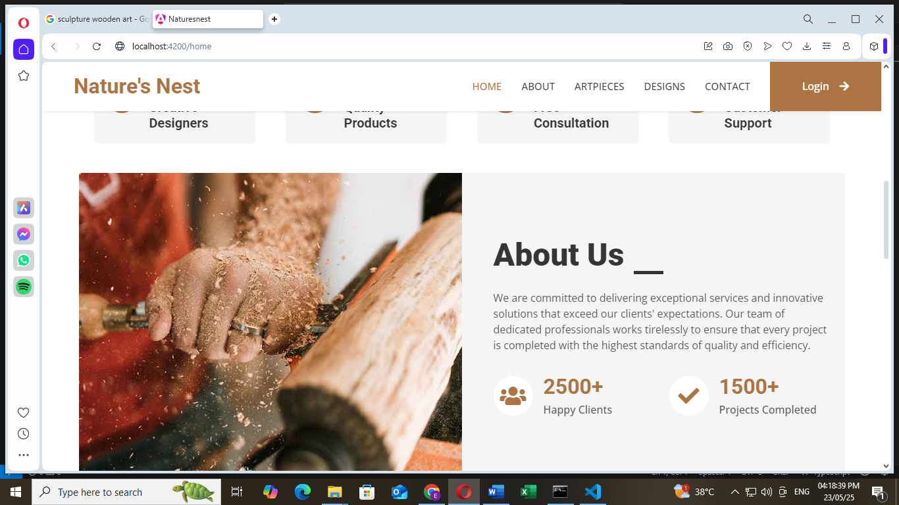

fig 4.1

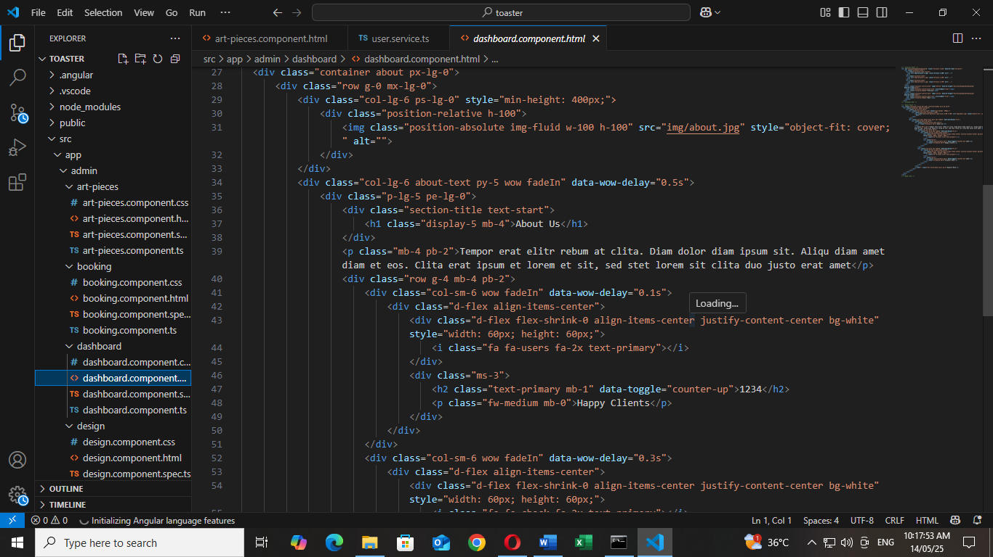

fig 4.2

**Login Page**

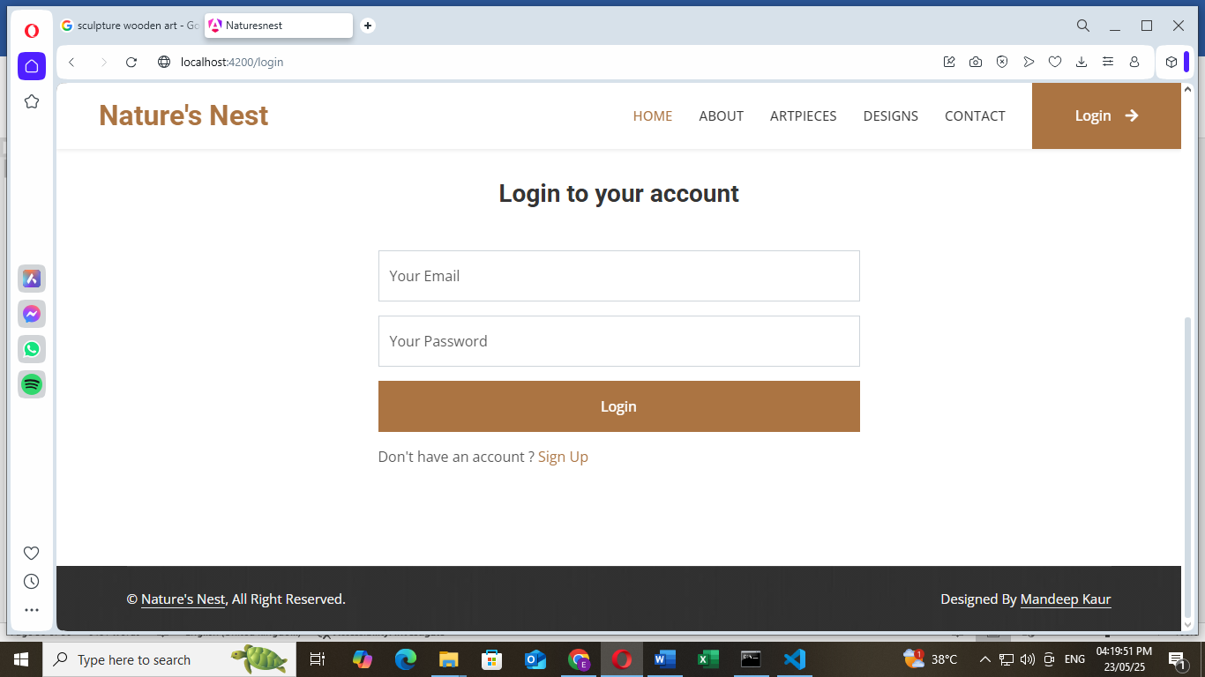

fig 4.3

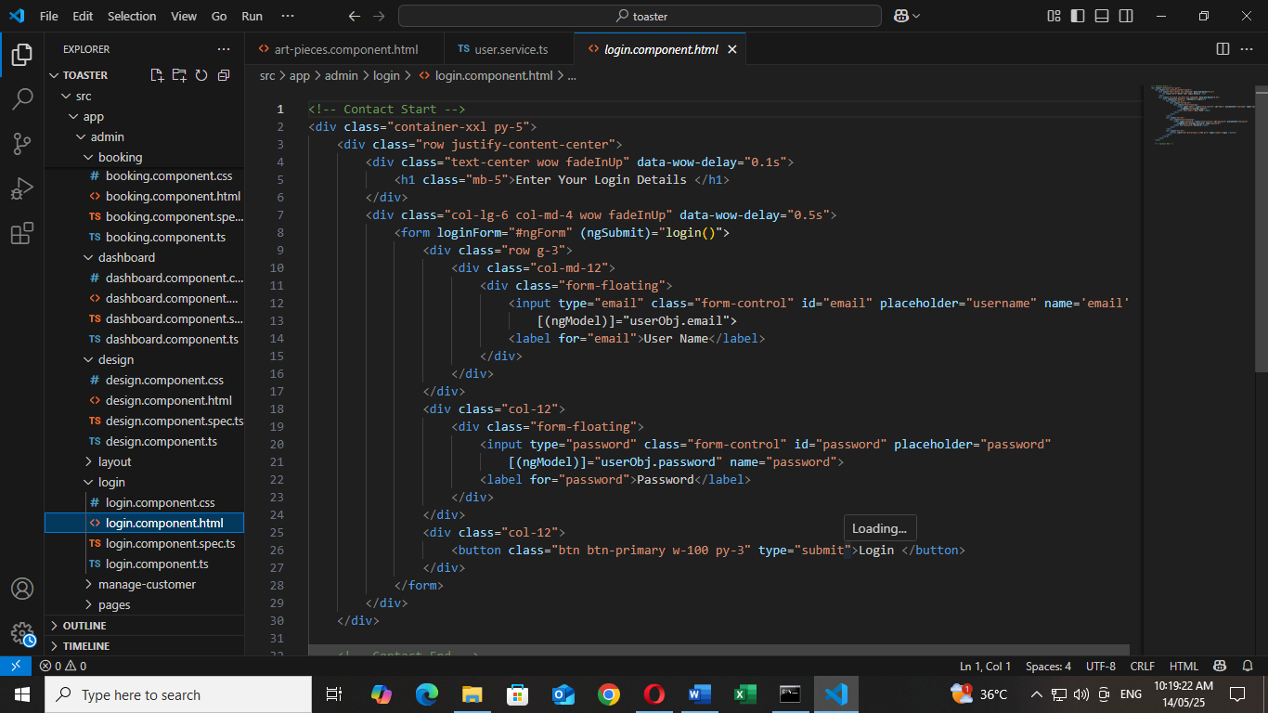

fig 4.4

Register Page

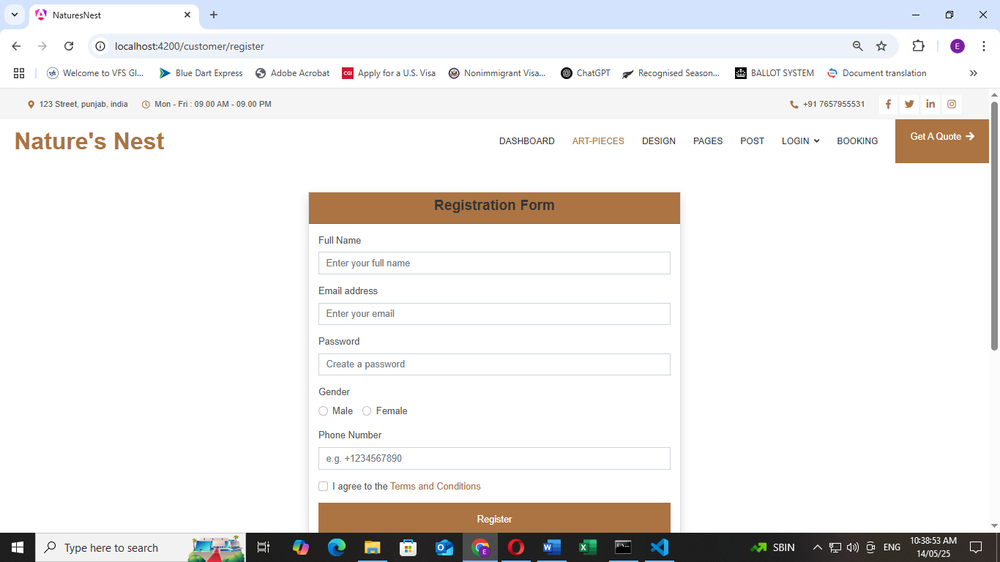

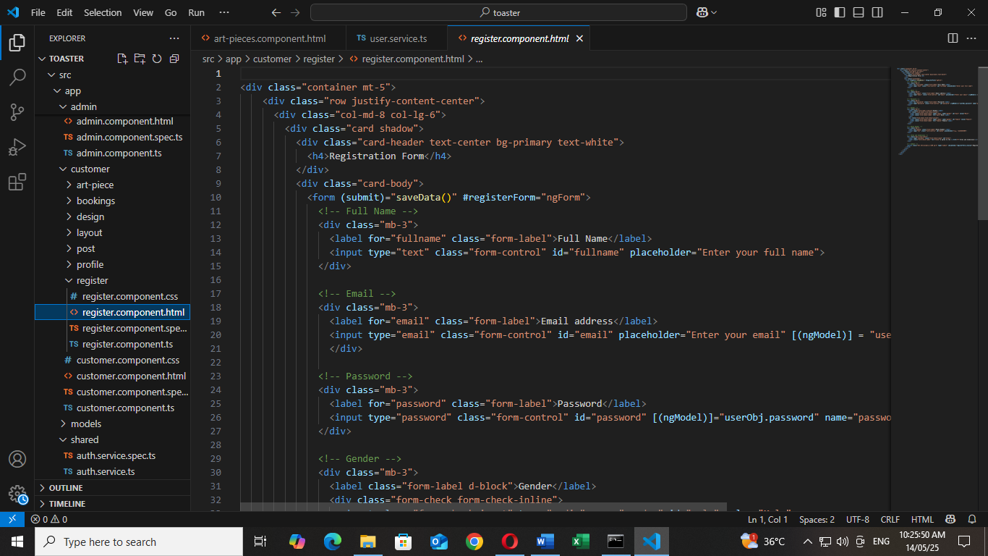fig 4.5

fig 4.6

Register and Login Page Service.ts File

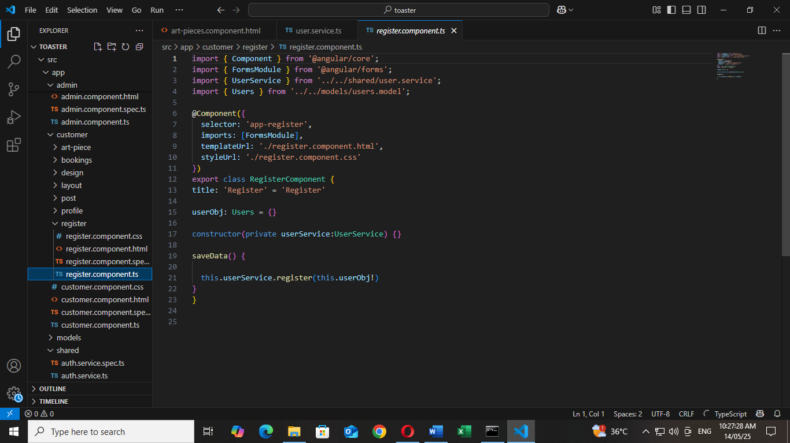

fig 4.7

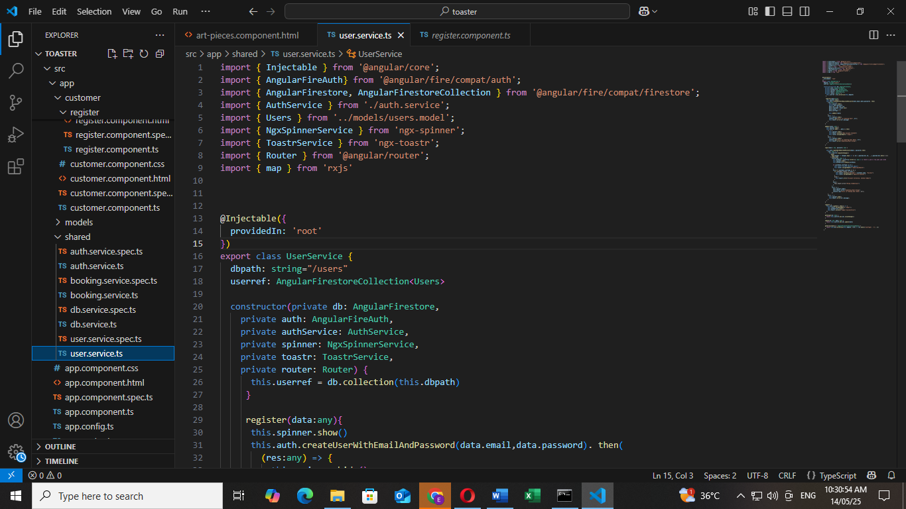

fig 4.8

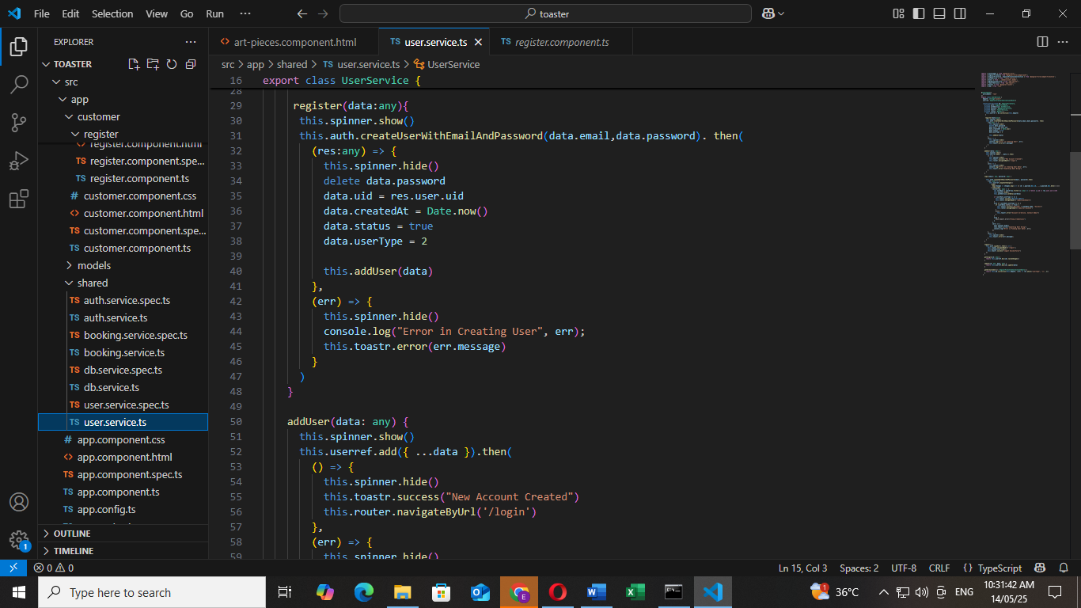

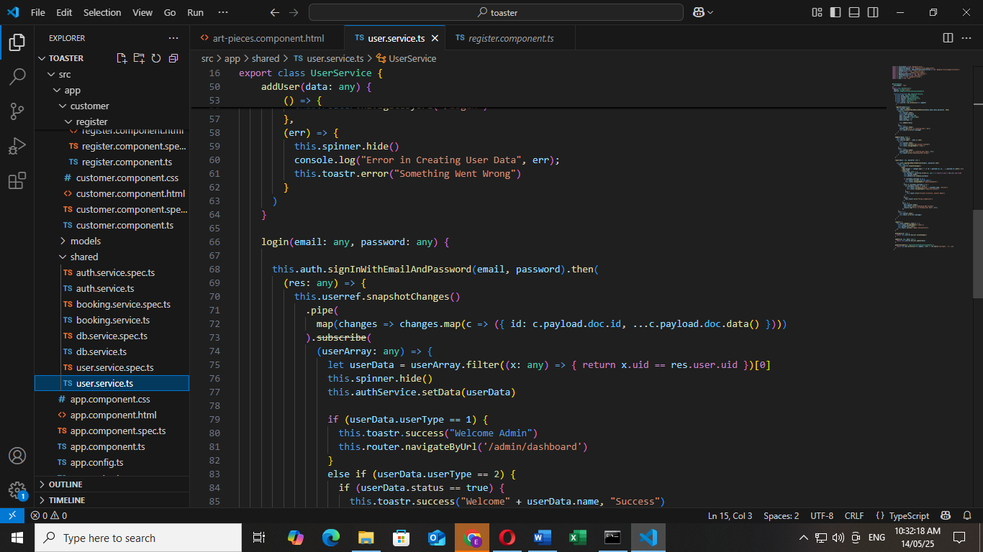fig 4.9

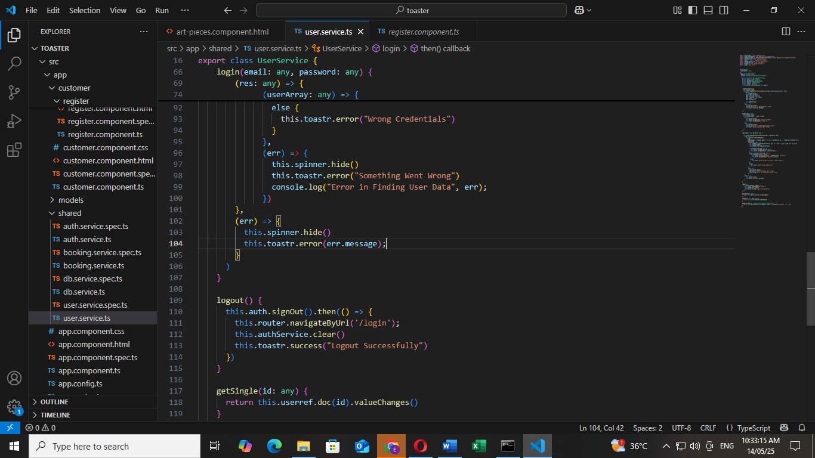

fig 4.10

**Routing**

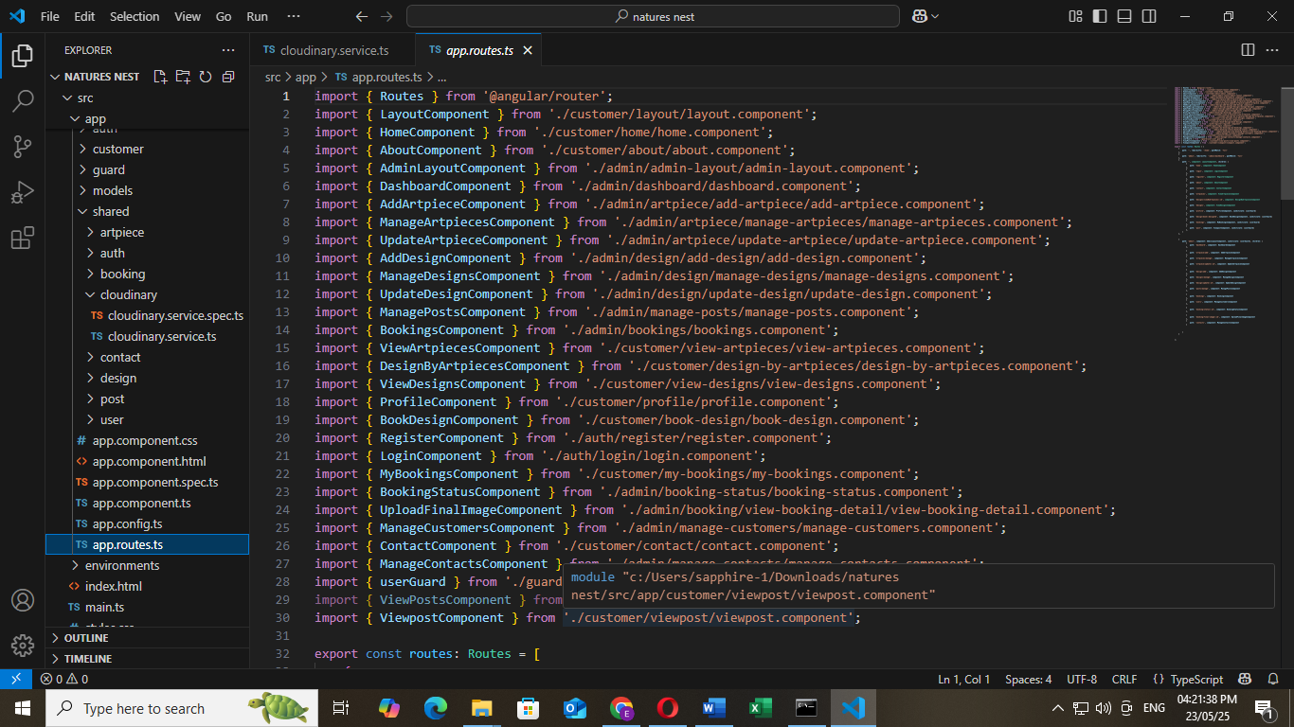

fig 4.12

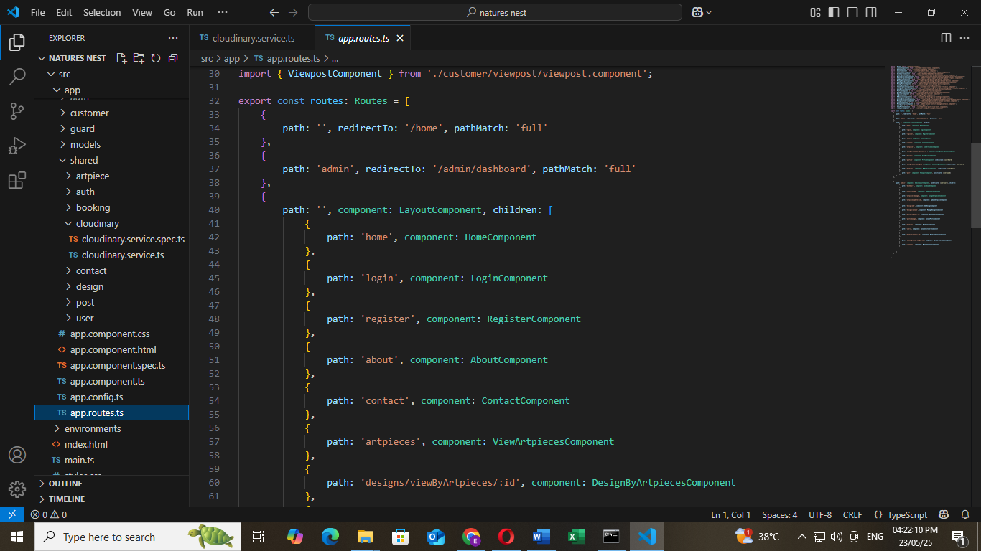

fig 4.13

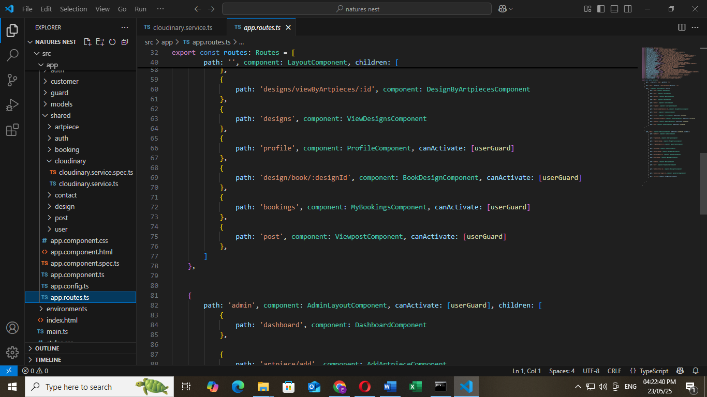

**Firebase DataBase**

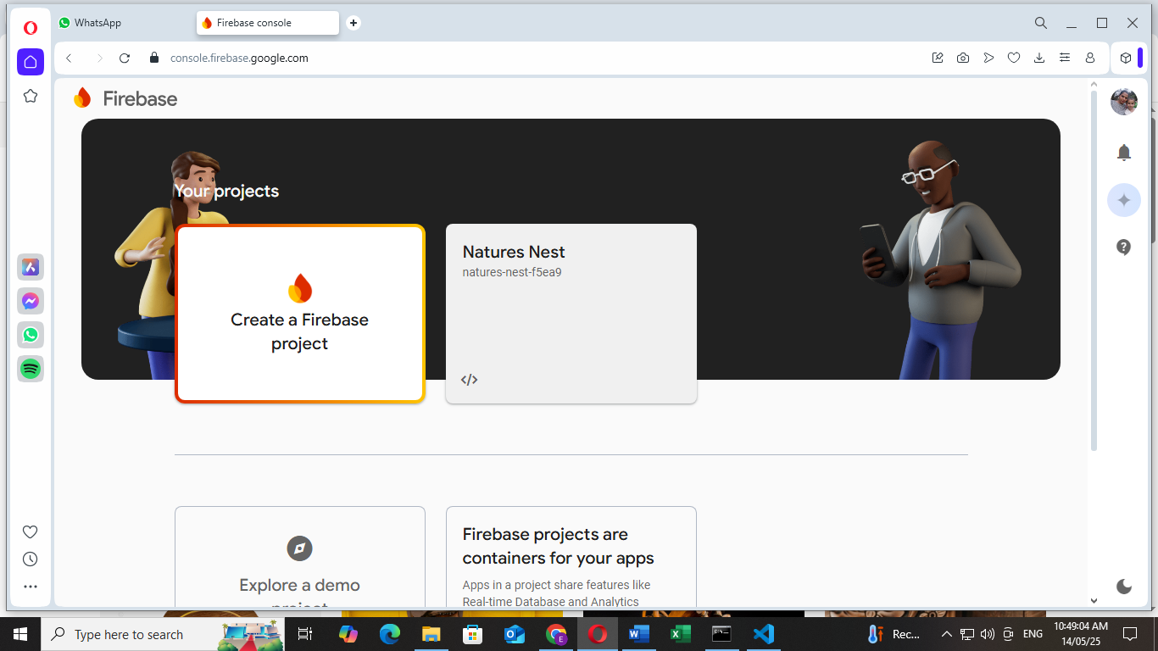

fig 4.14

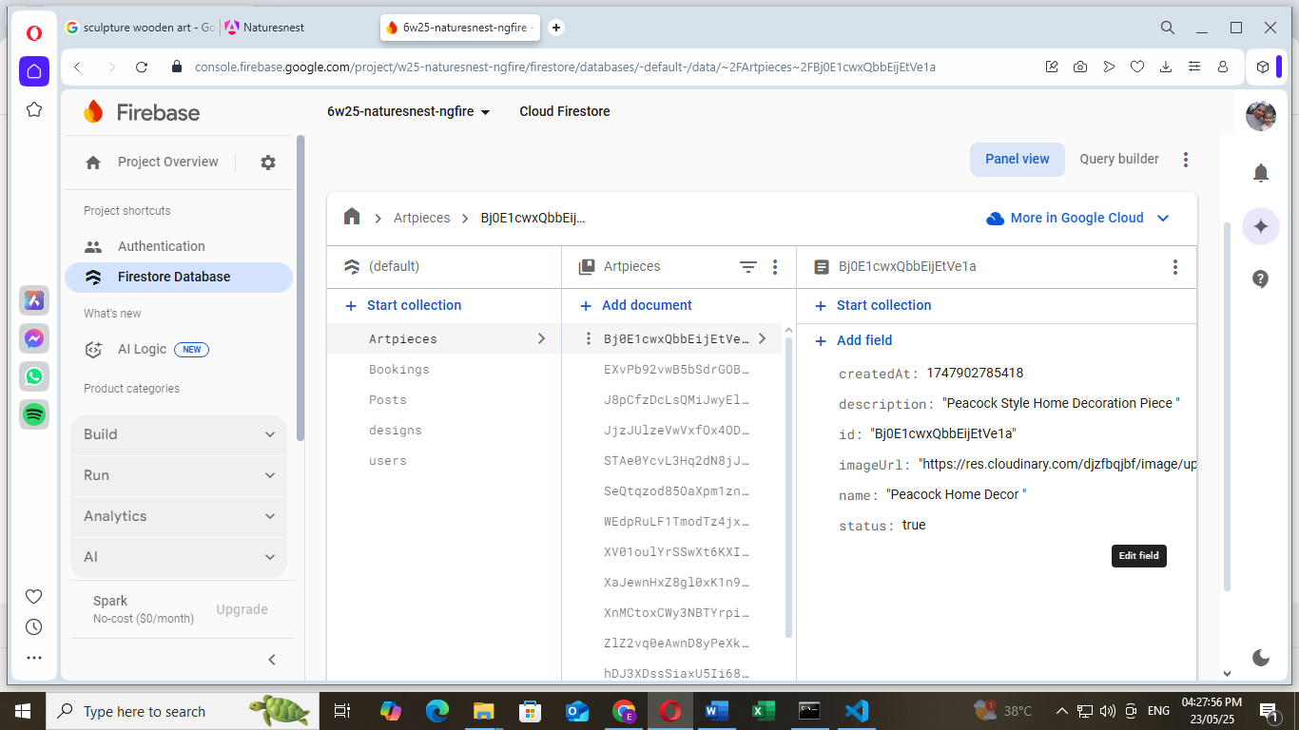

fig 4.15

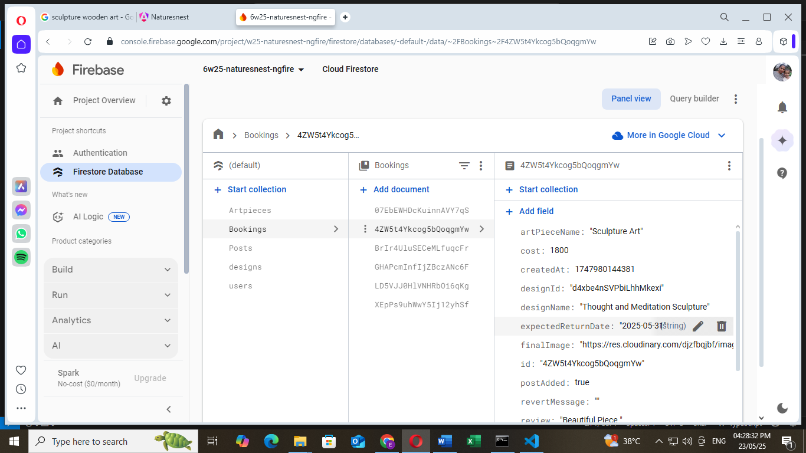

fig 4.16

**DFD’s**

Level 1

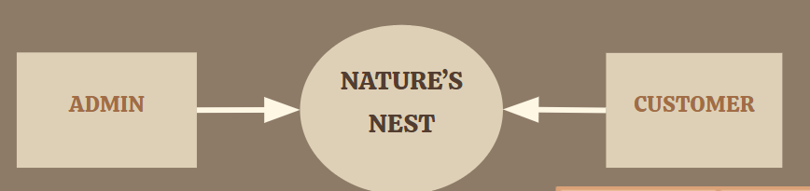

fig 4.17

Level 2

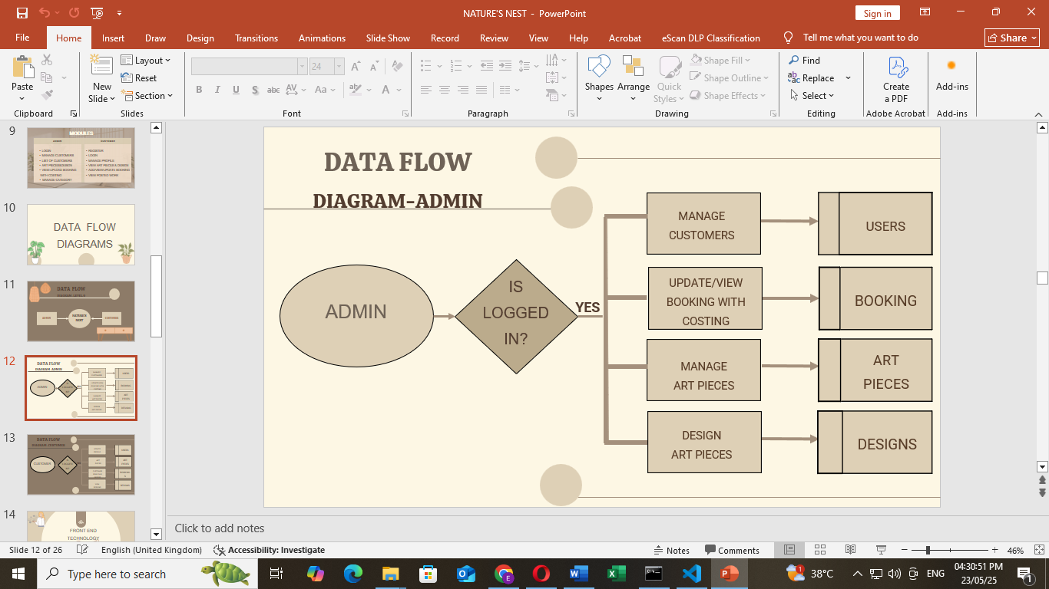

fig 4.18

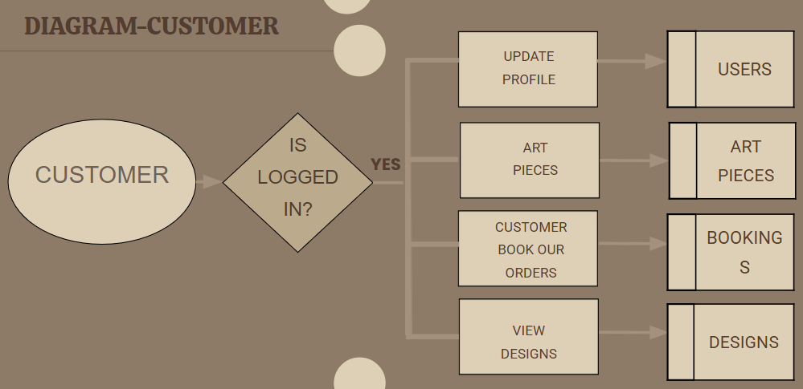Level 2 customer

fig 4.19

**CHAPTER 5**

**CONCLUSION**

The “Nature’s Nest” Wooden Art Piece Gallery and Online Website using Angular + Firebase offers a powerful and modern solution for an interactive and scalable platform. The combination of Angular's dynamic, component-based frontend and Firebase's real-time, serverless backend provides a robust foundation to build and expand our online business, offering a seamless user experience and easy deployment.

**Key Highlights:**

* 🌿 **Elegant & Responsive UI**: Angular enables a dynamic and intuitive user experience across devices, reflecting the natural aesthetic of the wooden art-pieces.
* 🔥 **Real-time Backend**: Firebase ensures fast and synchronized product updates, inventory management, and customer interactions.
* 🔐 **Secure User Authentication**: Firebase Authentication provides secure sign-in/sign-up features, protecting user data.
* ☁️ **Scalable Hosting & Database**: Firebase Hosting and Firestore allow the application to scale seamlessly with increased traffic or product listings.

By merging the warmth of handcrafted art with the efficiency of cloud-based technology, **Nature’s Nest** not only supports local artisans but also provides users with an enjoyable and trustworthy shopping experience.

This conclusion effectively summarizes the purpose of the website, encourages exploration, and emphasizes the appreciation for wooden art pieces.

**Future Scope**

The future of our Nature’s Nest website looks promising as we continue to evolve with the art and design landscape. With a growing global appreciation for sustainable materials and artisanal craftsmanship, we foresee expanding our collection to include more diverse styles and techniques from artists around the world. Embracing digital innovation, we aim to enhance user experience through virtual galleries, interactive features, and possibly augmented reality to provide a richer engagement with the artworks.

Furthermore, we plan to foster a community of artists and enthusiasts through forums, workshops, and collaborations, promoting knowledge sharing and creativity. As environmental consciousness grows, we are committed to highlighting the sustainability of wood as a renewable resource, partnering with eco-friendly initiatives, and promoting responsible practices.

* Innovation in design
* AI-Powered system
* Craftsmanship

**REFERENCES**

* + Frontend Web UI Frameworks and Technology Tools

edited by Dr. Ajay Bansal from Lovely Professional University.

* + Fundamentals of Web Programming

By Dr. Amit Sharma from Lovely Professional University.

* + Weblink: https://angular.dev/reference/configs/file-structure (Accessed on 12th May 2025)
  + Weblink: https://getbootstrap.com/ (assessed on 12th May 2025)
  + Weblink: https://firebase.google.com/docs/build (Accessed on 13th May 2025)